Revelation Chapter 16
Re 16:1 ¶ And I heard a great voice out of the temple saying to the seven angels, Go your ways, and pour out the vials of the wrath of God upon the earth.
2 And the first went, and poured out his vial upon the earth; and there fell a noisome and grievous sore upon the men which had the mark of the beast, and upon them which worshipped his image.
3 And the second angel poured out his vial upon the sea; and it became as the blood of a dead man: and every living soul died in the sea.
4 And the third angel poured out his vial upon the rivers and fountains of waters; and they became blood.
5 And I heard the angel of the waters say, Thou art righteous, O Lord, which art, and wast, and shalt be, because thou hast judged thus.
6 For they have shed the blood of saints and prophets, and thou hast given them blood to drink; for they are worthy.
7 And I heard another out of the altar say, Even so, Lord God Almighty, true and righteous are thy judgments.
8 ¶ And the fourth angel poured out his vial upon the sun; and power was given unto him to scorch men with fire.
9 And men were scorched with great heat, and blasphemed the name of God, which hath power over these plagues: and they repented not to give him glory.
10 And the fifth angel poured out his vial upon the seat of the beast; and his kingdom was full of darkness; and they gnawed their tongues for pain,
11 And blasphemed the God of heaven because of their pains and their sores, and repented not of their deeds.
12 ¶ And the sixth angel poured out his vial upon the great river Euphrates; and the water thereof was dried up, that the way of the kings of the east might be prepared.
13 And I saw three unclean spirits like frogs come out of the mouth of the dragon, and out of the mouth of the beast, and out of the mouth of the false prophet.
14 For they are the spirits of devils, working miracles, which go forth unto the kings of the earth and of the whole world, to gather them to the battle of that great day of God Almighty.
15 Behold, I come as a thief. Blessed is he that watcheth, and keepeth his garments, lest he walk naked, and they see his shame.
16 And he gathered them together into a place called in the Hebrew tongue Armageddon.
17 ¶ And the seventh angel poured out his vial into the air; and there came a great voice out of the temple of heaven, from the throne, saying, It is done.
18 And there were voices, and thunders, and lightnings; and there was a great earthquake, such as was not since men were upon the earth, so mighty an earthquake, and so great.
19 And the great city was divided into three parts, and the cities of the nations fell: and great Babylon came in remembrance before God, to give unto her the cup of the wine of the fierceness of his wrath.
20 And every island fled away, and the mountains were not found.
21 And there fell upon men a great hail out of heaven, every stone about the weight of a talent: and men blasphemed God because of the plague of the hail; for the plague thereof was exceeding great.

INTRODUCTION
In our previous study that Brother Chad Middick presented before the end of the year, he covered Revelation Chapter 15 which is considered by some to be a prelude or if only in part, a foretelling of what we’re going to see in more detail in our study of Chapter 16. Because it has been a few weeks since our brother Chad presented that study, it might be good to make a few helpful notes before continuing on with our study of Chapter 16.
But even before we do that, I’d like to make a few general notes. The first of which is just simply that while this has been an especially interesting study, my response to each question has much of the time has generated at least as many more questions. So, while I won’t attempt to explain all of the many things that I may not know, or yet have questions on myself, I do want to share with you what I feel like I have gained in my study of the chapter and would invite and even enjoy the discussion that we might participate in outside of the worship services. I believe that helps us all in a better understanding of the book.
Chapter 15 Review
What chapter 15 introduces us to is the Apostle John telling us of another sign in Heaven which he describes as great and marvelous. The detail to which John writes of in Chapter 15 is regarding seven angels having the seven last plagues, and that these plagues are representative of God wrath. Hendriksen notes these plagues as being the last plagues offer no opportunity for repentance. In verses 2-4 John tells us of a sea of glass mingled with fire, and those that had been victorious over the beast stood on this sea of glass and sang praises to the Lord God Almighty. In the last 4 verses John shows us a picture of the temple of the tabernacle of testimony being opened. The seven angels are given vials, or bowls that are to be used in pouring out of the seven last plagues of God’s wrath; describing Him (that is God) as the one who lives for ever and ever. The very last verse of Chapter 15 (verse 8) seems to mark a line between God’s patience and His wrath.
Re 15:8 And the temple was filled with smoke from the glory of God, and from his power; and no man was able to enter into the temple, till the seven plagues of the seven angels were fulfilled.
The place in which God is and that we are told is filled with smoke from the Glory of God and His Power is the place that “no one would be permitted to enter. If you recall there was a part of the Temple that was called the Holy of Holies where God could reside with man and yet be separate or set apart from him. This place was a place that only the High Priest, as chosen by God, could enter once a year for the purpose of first making intercession for himself, and then for the people. So, it is significant that the last verse in chapter 15 points out that no man could enter the temple due to the smoke of God’s glory and power until the seven plagues of the seven angels had been fulfilled. What that means is that no man could enter the place that was designated by God for making intercession until these plagues of God’s wrath had been poured out and fulfilled. If no man would be allowed to enter until after the bowls of God’s wrath had been poured out,
then God was drawing a line between the time of His mercies and a time when repentance was no longer acceptable.
In the letter to the Church at Leodicea it is portrayed that God is outside knocking on the door petitioning to come in and be with His children, if they would but open the door unto Him.
Re 3:19 As many as I love, I rebuke and chasten: be zealous therefore, and repent.20 Behold, I stand at the door, and knock: if any man hear my voice, and open the door, I will come in to him, and will sup with him, and he with me.
But it appears that in this case that the knocking has ceased and repentance was no longer an option.
You might note that in all of the associated terribleness of these plagues, not once did they repent. But instead they blaspheme the name of God and His glory. Vs 9, 11 clearly states “they repented not.”
Something that I’d like to quickly mention is that this is something that is not even comprehendible for me. I look at the martyrs that were beheaded for the witness of Jesus and the word of God. Those people had to have been committed. They were committed to the point of giving their lives to gain eternity. Think of the depths to which those that had the mark of the beast had to have been deceived such that they would not only give their lives, but they would give their souls and promise of eternal life. Do you remember how Satan tempted the savior?
Mt 4:8 Again, the devil taketh him up into an exceeding high mountain, and sheweth him all the kingdoms of the world, and the glory of them;9 And saith unto him, All these things will I give thee, if thou wilt fall down and worship me.10 Then saith Jesus unto him, Get thee hence, Satan: for it is written, Thou shalt worship the Lord thy God, and him only shalt thou serve.
“I’ll give you the world and all of its kingdoms….and all you have to do is fall down and worship me (Satan). Give me your soul.”
Mt 16:26 For what is a man profited, if he shall gain the whole world, and lose his own soul? or what shall a man give in exchange for his soul?
But when I look at someone that the plagues of God’s wrath have been directed at, and who would refuse to repent, but instead blaspheme the name of God,…that’s a deception way beyond my ability to comprehension. They had to have been so thoroughly deceived that they were beyond feeling or comprehension. And this is the lesson. This is how deception works and is just how totally and completely through the influences of the world that Satan is committed to causing us to lose our souls and our place in the book of life. Now, if I haven’t already gotten too far ahead of myself.
Chapter 16
Chapter 16 begins with a command that is described as coming from a great voice out of the temple to pour out the vials of God’s wrath upon the earth. It then describes each of the seven plagues in order as they are poured out and is then descriptive of the resulting impacts of each.
Re 16:1 ¶ And I heard a great voice out of the temple saying to the seven angels, Go your ways, and pour out the vials of the wrath of God upon the earth.
Some things that Summers makes note of in his book, “Worthy is the Lamb”, is some of the similarities and differences between the bowls of God’s wrath and the trumpets spoken of in chapters 8 through 10. He notes,
“They represent woes upon nature and upon man; and, like the trumpets, a part of their symbolism is parallel with the Egyptian plagues. However, the trumpet judgments were calls to repentance; the bowl judgments are visitations of punishment when hope of repentance is passed.”
Summers also notes that the trumpet judgements were partial in that they only impacted a third part of their objects, while the bowl judgements affected a totality of their object. Additionally, the trumpets did not directly affect man until the fifth trumpet while the bowls of God’s wrath impacted man directly from the very first.
Chapter 16 groups the seven bowls of God’s wrath in the following manner.
- First four bowls are upon nature, but their impacts were definitely felt by man
- The fifth and sixth bowls are specifically upon man
The affects of each of these bowls seem to be progressive or, in other words, cumulative with the pouring out of each bowl. As is the case with several of what we’ve been referring to as recapitulations, there is a short interlude between the sixth and the seventh, in this case bowls. Following the pouring out of the 6th bowl John describes his vision of the formation of Satan’s army in something of a word picture that involves three unclean spirits that are like frogs. These frog-like creatures are said to come forth from the mouths of the Dragon, the Beast and the 2nd beast or false prophet. We’ll look a little more closely at this as we progress into our study of the chapter. For now, let’s look at each of the plagues and their specific impacts.
What are the seven bowls (vials) of God’s wrath?

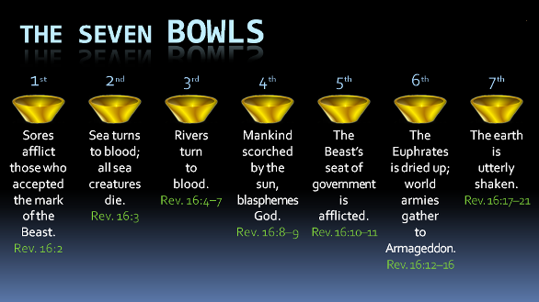
2 And the first went, and poured out his vial upon the earth; and there fell a noisome and grievous sore upon the men which had the mark of the beast, and upon them which worshipped his image.
Other translations of noisome and grievous sore are and
- Evil and poisoning
- Loathsome and painful
- Foul and loathsome

When I think about this first plague, my mind goes to Job and the suffering that he endured while being covered with these from the sole of his foot unto his crown. As we might say from the top of his head to the bottom of his foot. The Bible tells us that he took a broken piece of pottery to scape these sores with.
Commentators will also draw attention to the invisible mark of the beast as spoken of in Rev 13:16. With the pouring out of the first bowl, those that bore the mark of the beast were no longer hidden in that they were the ones being impacted with these sores.

Additionally, scholars and commentators will draw a parallel to the seventh plague upon Egypt.

Ex 9:10 And they took ashes of the furnace, and stood before Pharaoh; and Moses sprinkled it up toward heaven; and it became a boil breaking forth with blains upon man, and upon beast.11 And the magicians could not stand before Moses because of the boils; for the boil was upon the magicians, and upon all the Egyptians.

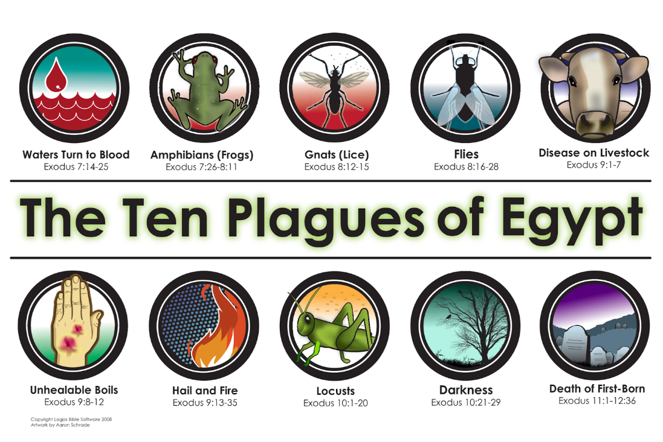
3 And the second angel poured out his vial upon the sea; and it became as the blood of a dead man: and every living soul died in the sea.
Please note that when the second vial or bowl was poured out upon the sea and the sea became blood, every living creature in the sea died. This somewhat parallels the second trumpet over in Revelation 8:8-9 except that when the second trumpet was sounded it resulted in
Re 8:8 … the third part of the sea became blood; 9 And the third part of the creatures which were in the sea, and had life, died; and the third part of the ships were destroyed.
Like the trumpets, they represent woes upon nature and upon man; and like the trumpets, a part of their symbolism is parallel with the Egyptian plagues. In this case the parallel of both the second and third bowls would be to the
Ex 7:17 ….. behold, I will smite with the rod that is in mine hand upon the waters which are in the river, and they shall be turned to blood.18 And the fish that is in the river shall die, and the river shall stink; and the Egyptians shall lothe to drink of the water of the river.19 And the LORD spake unto Moses, Say unto Aaron, Take thy rod, and stretch out thine hand upon the waters of Egypt, upon their streams, upon their rivers, and upon their ponds, and upon all their pools of water, that they may become blood; and that there may be blood throughout all the land of Egypt, both in vessels of wood, and in vessels of stone. …..21 And the fish that was in the river died; and the river stank, and the Egyptians could not drink of the water of the river; and there was blood throughout all the land of Egypt.
4 And the third angel poured out his vial upon the rivers and fountains of waters; and they became blood.
As opposed to the second bowl which turned all the seas into blood, when the third bowl is poured out, it affects fresh water; meaning rivers and springs of water. This is also compared to the Egyptian plague when the Nile is turned into blood as is previously mentioned over in Exodus 7: 17-2.
5 And I heard the angel of the waters say, Thou art righteous, O Lord, which art, and wast, and shalt be, because thou hast judged thus. 6 For they have shed the blood of saints and prophets, and thou hast given them blood to drink; for they are worthy. 7 And I heard another out of the altar say, Even so, Lord God Almighty, true and righteous are thy judgments.
In verses 5-7 the Apostle John tells us that he hears a voice proclaiming the righteousness of God in executing this plague. Just over in the previous chapter 15:3-4 the songs of Moses and the Lamb are sang.
Re 15:3 … saying, Great and marvellous are thy works, Lord God Almighty; just and true are thy ways, thou King of saints. 4 Who shall not fear thee, O Lord, and glorify thy name? for thou only art holy: for all nations shall come and worship before thee; for thy judgments are made manifest.
I don’t know if there is any significance to the fact that the voice is said to be that of the angel of the waters. My assumption would be that this is in reference to the angel that poured out the third bowl of God’s wrath.
Summers states the following in reference to this third plague of God’s wrath.
“He (that is God) visits punishment in accordance with sin: Once the Empire had made the blood of the martyrs run like water; now all the Empire can find to drink is blood---and they deserved it. God’s judgements are righteous.”
The wording that Summers uses is that they deserved this specific punishment. His specific wording seems to convey a component of angry vengeance. The KJV translation conveys it in term of them being “worthy” of this specific punishment. In other words, they had earned it. Resseguie in his commentary “The Revelation of John”, states it in terms of the punishment being tailored to fit the crime. Do you remember when we were studying the opening of the seals. When the fifth seal was opened in Chapter 6:9 John writes,
Re 6:9 ¶ … I saw under the altar the souls of them that were slain for the word of God, and for the testimony which they held:10 And they cried with a loud voice, saying, How long, O Lord, holy and true, dost thou not judge and avenge our blood on them that dwell on the earth? 11 And white robes were given unto every one of them; and it was said unto them, that they should rest yet for a little season, until their fellowservants also and their brethren, that should be killed as they were, should be fulfilled.
Since they had been responsible for shedding the blood of faithful martyrs, it was just that they should be deprived of drinking water and instead have to partake in the drinking of the blood of those that they taken that life-giving blood from. Leviticus 17:14 states that the life of all flesh is the blood thereof: whosoever eateth it shall be cut off.
8 ¶ And the fourth angel poured out his vial upon the sun; and power was given unto him to scorch men with fire. 9 And men were scorched with great heat, and blasphemed the name of God, which hath power over these plagues: and they repented not to give him glory.
The fourth bowl of God’s wrath is poured out upon the Sun. This gave the fourth angel power to scorch men with fire and great heat. The fact that the bowl was poured out on the Sun, may be to emphasize the measure of heat which this angel had the ability to cause those with the mark of the beast to suffer. The source of the heat with which he scorched men was the heat of the Sun and I think that it may be intended for the picture of apocalyptic writing here to stretch the imagination of men to understand the burning pain associated with the plague that was now being applied to those with allegiances to the Devil.
I think that its noteworthy that in amongst what might be viewed as pain that can only be imagined, this is the first plague of God’s wrath that clearly states that those who bore the mark of the beast “blasphemed the name of God, which hath power over these plagues: and they repented not to give him glory.” The degree of pain associated with God’s punishment is further emphasized in the description of the fifth bowl of God’s wrath in verses 10-11.
10 And the fifth angel poured out his vial upon the seat of the beast; and his kingdom was full of darkness; and they gnawed their tongues for pain, 11 And blasphemed the God of heaven because of their pains and their sores, and repented not of their deeds.

- first bowl was poured out on the earth
- Second bowl was poured out on the sea
- third bowl was poured out on the rivers and springs (fresh waters)
- fourth bowl was poured out on the Sun
- fifth bowl is now poured out on the seat of the beast.
What was the meaning of the seat or the throne of the beast? If we were to think of the county seat, don’t we think in term of the central location of county government. If we look at a translation that renders this as the throne of the beast, wouldn’t that be in reference to the place from which he rules his followers. In this case, I believe that it has to do with Roman or antichristian governments of the world. The mention of the throne of the beast is noted by commentators as a counterfeit of that which is devine and in imitation of the Throne of God. In chapter 13 and verse 2 the beast is said the receive power and authority from the throne of the dragon. We’ll come back to this thought of mockery and imitation in verses 13-16.
This fifth plague darkens the kingdom of the beast. I’m not exactly sure of what specific meaning might be attached to the darkness that now envelopes that kingdom of the beast. It might have to do with the suffering and despair of one who is the recipient of God’s wrath. Resseguie’s thoughts regarding this darkness seems reasonable. He says,
“The physical darkness thrust upon the beast’s kingdom corresponds to the religious, moral, and political darkness that characterizes the beast’s reign.”
The darkness is something that seems to compound and to be progressive regarding the pain of those who were followers of the beast. Verse 11 paints the gruesome picture of the ungodly gnawing at their tongues because of their pains and because of the sores that were a result of the pouring out of the first bowl.
12 ¶ And the sixth angel poured out his vial upon the great river Euphrates; and the water thereof was dried up, that the way of the kings of the east might be prepared.
The sixth bowl is poured out on the great river Euphrates and dries up the river. I don’t know of the significance since the Euphrates river was dried up by the pouring out of the sixth bowl, but the river would have been full of blood in keeping with the pouring out of the third bowl. Forgive me if you see me struggle with the picture that is being painted and the physical descriptions that are used to paint them. Perhaps the greater point is that drying up the Euphrates created a vulnerability for Babylon. Resseguie perceives the Euphrates which ran through Babylon as the antithesis of the river of the water of life which flows through New Jerusalem as described in Revelation 22:1 as a pure river of water of life, clear as crystal, proceeding out of the throne of God and of the Lamb.
There are many differing thoughts from the imagery that is given relative to the pouring out of the sixth bowl and who were the kings of the East whose way was prepared by the drying of the Euphrates. We may want to be careful not to lose sight of the bigger picture. Albertus Pieters mentions a perspective provided by a Dr. Greijdanus, who looks at the Euphrates as the symbolical prophetic boundary between Christendom and Heathondom.
13 And I saw three unclean spirits like frogs come out of the mouth of the dragon, and out of the mouth of the beast, and out of the mouth of the false prophet. 14 For they are the spirits of devils, working miracles, which go forth unto the kings of the earth and of the whole world, to gather them to the battle of that great day of God Almighty.
We learn in verse 16 that this place is called in the Hebrew tongue Armageddon.
Commentators have given the title of the Unholy Trinity to the Dragon, the Beast and the False Prophet. The reason for this is that each represents what commentators refer to as counterfeits or mockeries of the God Head.
Dragon – Represents Satan
Re 12:9 And the great dragon was cast out, that old serpent, called the Devil, and Satan, which deceiveth the whole world: he was cast out into the earth, and his angels were cast out with him.

In Revelation 13:1-10 we learn of the first beast and how the dragon (Satan) gives life and authority to this beast (the dragon’s image). Emerson (Between the Cross and the Throne) states, “This mocks the Father’s granting of life and authority to the Son in his resurrection and ascension, as well as the Son’s status as the image of the Father
Beast – Corrupt Civil Government
Even as Christ is the image of God (Col 1:15; Heb 1:3), the beast is the image of the dragon. Additionally, in Revelation 17:11 the beast is described as the one who was and is not. Emerson also identifies this as a counterfeit or mockery of Christ, who is the one who was and is and is to come. Adding to this identification as the unholy trinity there is an attempt of the beast to identify or mock Christ in terms of rulership. While Jesus rules over God’s people, the beast rules over God’s enemies.
Re 13:4 And they worshipped the dragon which gave power unto the beast: and they worshipped the beast, saying, Who is like unto the beast? who is able to make war with him?
Re 13:7 And it was given unto him to make war with the saints, and to overcome them: and power was given him over all kindreds, and tongues, and nations. 8 And all that dwell upon the earth shall worship him, whose names are not written in the book of life of the Lamb slain from the foundation of the world.
One additional way that the beast attempts to imitate / counterfeit or mock Jesus is his ability to overcome death. The beast is healed or brought back from a fatal wound in Revelation 13:3, which would be to imitate the death and resurrection of Jesus.
Re 13:3 And I saw one of his heads as it were wounded to death; and his deadly wound was healed: and all the world wondered after the beast.
The Second Beast / False Prophet
The last of the unholy trinity is the second beast, who is also referred to as the false prophet. Just as the dragon mocks the Father and the beast mocks the Son (Jesus), the false prophet attempts to imitate or make a mockery of the Holy Spirit. He did this by imitating
- Raising the beast from his mortal wound even as the spirit raised Christ from the dead (Rom 8:11).
- Causes people to follow the beast
- Performs signs that resemble the works of The Spirit (Rev.13:13
- Marks the enemies of God in the forehead with the number of the beast even as The Spirit seals the followers of God with the name of God in their foreheads (Rev. 7:3, Eph. 1:13)
Interesting side note: I don’t really know that there’s any specific significance to it, but the followers of God were sealed and the Satan’s followers were marked.
The image that comes to mind when we consider the unholy trinity is that of a mirror in the respect that the reflected image is the same, but exactly opposite. Perhaps I can illustrate that by considering that raising your right hand appears as if the reflected image has raised their left hand. Exactly opposite of what has actually happened. So the dragon, the beast and the false prophet in an attempt to imitate The Father, The Son and The Holy Spirit are the exact opposite of the God Head.
These three frog-like characters come out of the mouths of the Unholy trinity. This could possibly be in reference to the means by which they deceived the Kings and armies of the world to amass for battle on the side of Satan. They were said to have worked many miracles and spread much propaganda (thus coming forth from the mouth of the Dragon, Beast and False Prophet) to deceive the world and to gather them in preparation for the final battle of Good and evil
15 Behold, I come as a thief. Blessed is he that watcheth, and keepeth his garments, lest he walk naked, and they see his shame.
If you have a red-letter edition of the Bible you will find that this verse is in red letters and therefore are to be interpreted as being the words of Jesus. Verse 15 was both a warning and an encouragement that His coming would be sudden and unexpected even as a thief might enter into a place from which he would steal from. The analogy is not to be taken as a comparison of Jesus to a thief outside of His warning to maintain a constant state of preparedness; unfaultering in ones faithful living even under the worst of circumstances. Blessed is he that watcheth, and keepeth his garments.
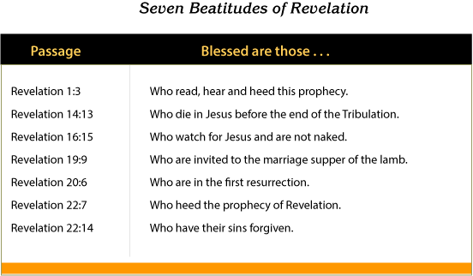
It’s a very interesting analogy that is used in that it speaks of one who keeps their garments on rather than to be who is naked and exposed where everyone can see your shame. In the remaining chapters of this book we will find descriptions and contrasts regarding the bride of Christ and the Harlot. A bride is someone who adorns herself in a wedding gown that is the picture of purity in anticipation of the bridegroom. Whereas a Harlot would be representative of something very different and know rather for her nakedness and therefore very much unprepared and ashamed at the coming of the bridegroom.
Armageddon
Commentators will explain that the great Eschatological battle that is spoken of in verse 16 is not one that will be found on a physical map, but rather a spiritual one. The battle is between good and evil, and righteousness is the victor. Perhaps it was a place that the recipients of this book would be familiar with in terms of a well-known battle ground where notable and decisive battles had been fought. In Hebrew this place is called Harmagedon which translates into mountain of Megiddo. So
17 ¶ And the seventh angel poured out his vial into the air; and there came a great voice out of the temple of heaven, from the throne, saying, It is done. 18 And there were voices, and thunders, and lightnings; and there was a great earthquake, such as was not since men were upon the earth, so mighty an earthquake, and so great. 19 And the great city was divided into three parts, and the cities of the nations fell: and great Babylon came in remembrance before God, to give unto her the cup of the wine of the fierceness of his wrath. 20 And every island fled away, and the mountains were not found. 21 And there fell upon men a great hail out of heaven, every stone about the weight of a talent: and men blasphemed God because of the plague of the hail; for the plague thereof was exceeding great.
The seventh bowl is pour out into the air and God declares that “It is done”. Time as we know it is no more.
10:6 And sware by him that liveth for ever and ever, who created heaven, and the things that therein are, and the earth, and the things that therein are, and the sea, and the things which are therein, that there should be time no longer:
When the last of the seven vials (bowls) are poured out into the air. Hendrikson, indicates that when this happens, life on earth is about to come to an end. There is a universal finality to it. John hears this announcement from the Throne of God with authority. With this final bowl there are voices and thunderings and lightnings and earthquakes the likes that have never been in the history of men. They were so powerfully devastating that islands disappeared into the sea and mountains disappeared into rubble. And then finally Hail stones that were said to have weighed just short of 100 lbs. each fell, as summers says with destructive force. One of Brother Johnny Elmore’s questions relate to whether or not these hailstones were capable of killing instantly. I would assume that anything of that size and weight would certainly have that ability in a physical world.
Don McCord stated that ungodly men would pay a great price for their stubborn impenitence. The Great city was divided into three parts. I must confess that I do not understand the significance of the great city of Babylon being divided into three. Many scholars and commentators will simply speak in reference to the dividing of Babylon as it being broken into pieces. Summers says that when this happens, the entire antichristian empire, viewed sa a center of seduction, the whole kingdom falls apart and is destroyed. Its cities and nations are ruined.
“In this great day of Judgement it becomes evident that God has not forgotten the sins of Babylon after all.”
God had pent up His wrath for Babylon and now brings that into remembrance in this seventh and final plague.

