Revelation 3:14-22
14) And to the angel of the church of the Laodiceans write, ‘These things says the Amen, the Faithful and True Witness, the Beginning of the creation of God:
15) “I know your works, that you are neither cold nor hot. I could wish you were cold or hot.
16) So then, because you are lukewarm, and neither cold nor hot, I will vomit you out of My mouth.
17) Because you say, ‘I am rich, have become wealthy, and have need of nothing’ – and do not know that you are wretched, miserable, poor, blind, and naked –
18) I counsel you to buy from Me gold refined in the fire, that you may be rich; and white garments, that you may be clothed, that the shame of your nakedness may not be revealed; and anoint your eyes with eye salve, that you may see.
19) As many as I love, I rebuke and chasten. Therefore, be zealous and repent.
20) Behold, I stand at the door and knock. If anyone hears My voice and opens the door, I will come in to him and dine with him, and he with Me.
21) To him who overcomes I will grant to sit with Me on My throne, as I also overcame and sat down with My Father on His throne.
22) He who has an ear, let him hear what the Spirit says to the churches.

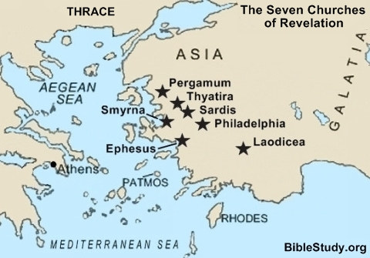
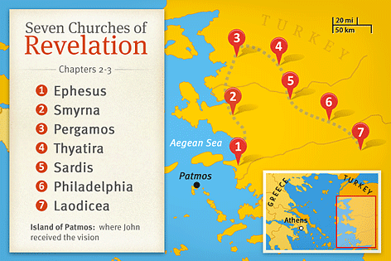
Introduction:
Christ’s letters to the churches in Asia minor was in geographical order as though walking from one church to the next nearest of the seven. He starts with Ephesus and travels north until Pergamum. From there, He travels south east until he arrives to a beautiful city named Laodicea. It was founded by Antiochus II, who named the city after his wife. 13 miles from the city was a notable school of medicine. This school developed an eye medicine known as Phrygian power in order to make weak eyes stronger. The surrounding area was also famous for a special breed of sheep that produced soft, glossy, black wool that was used to make highly sought after garments.
Laodicea was famous for its wealth. In 60 AD the city was hit by a major earthquake. The city had such excess in wealth that its citizens declined financial aid from the Roman government and rebuilt the infrastructure themselves. The Church of Christ in Laodicea manifested this same proud, defiant, conceited attitude. It’s likely some members of the Lord’s body viewed their financial success as God’s special favor, but as we’re about to see they would have been wrong to imagine such.
The time this congregation was established remains unknown. It may have been during Paul’s stay in Ephesus according to Acts 19:10. What we do know is that a neighboring congregation 10 miles from Laodicea received a letter from Paul and in this letter Paul references believers in Laodicea 4 times.
This is what he has to say:
Colossians 2:1 – Paul desired comfort for them at Colossae and in Laodicea
Colossians 4:13 – Paul expresses great zeal for them in Laodicea
Colossians 4:15 – Paul refers to Laodicea as brethren.
Colossians 4:16 – Paul instructs the letter the Colossians have received to be read to the Laodiceans and that the Colossian church would read a letter written to Laodicea.
The evidence leads us to believe there was a church in Laodicea and it was established as early as the 50’s AD the time the Colossian letter was written.
- Descriptions of Christ
14) And to the angel of the church of the Laodiceans write, ‘These things says the Amen, the Faithful and True Witness, the Beginning of the creation of God:
The Amen
This is the only place that it is spoken of as a proper name. The term here applied to the Lord signifies that Christ Himself is the fulfillment of all that God has spoken to the churches.
The Hebrew meaning of Amen in this passage is akin to ‘Truth’ and is intended to express certainty or lack of doubt.
The Faithful and True Witness
Faithful and True describe the type of Witness Christ is.
According to Trench, three things are necessary to be a witness:
- They must have a first-hand knowledge of that to which they testify and must have seen with their eyes that which they attest.
- They must be competent to reproduce and relate this for others.
- They must be willing to make this known faithfully and truly.
Christ completely fulfills these essentials.
The Beginning of the creation of God
I remember in history class when I was in high school we arrived to the topic of Jesus of Nazareth. I was surprised to see His name in a history book not because His existence was in question but because I had not been given any secular teaching on Christ before. A few things struck and stuck with me and they are the following:
(1) The text painted Jesus in soft colors as a plain humble man who had a beginning and an end. Phrases like “He was a good man”, “He instilled his followers with pacifism and peace”.
(2) Despite overcoming death and restoring the bridge of relationship between mankind and God the Father, Christ only afforded a paragraph in this 400 page history book. Not a chapter. Not even a page.

Friends,
Christ was more than man. He was man, but He is God. He never stopped being God. Paul says “In Him dwells the fullness of the Godhead bodily.” Col 2:9
The earth has been visited by heavenly entities at various times according to scripture but angels are still creatures. They were created. Jesus was not created, He is the beginning. The revealed alpha. He took an upside down bell curve from the portals and beauty of heaven and took on flesh in a world of heat, thirst, and dust. Then in fulfillment of mission he ascended back to His rightful place. Nothing like Christ has ever come to earth and nothing ever will. He knows the name of every person born, where they went to school, what they became, and who they could have been. He’s here standing before John the fearful stenographer and says “I know your works”
- Temperature of Laodicea’s works
15) “I know your works, that you are neither cold nor hot. I could wish you were cold or hot.
“I know your works” should relieve the productive believer who wakes in the morning and is excited to share the good news with the world another day. Those words did not produce the same joy for Laodicea. They are fully aware of the deeds they’ve done and now they hear how their works have been received by the True and Faithful Witness. He says your works are neither cold nor hot.
There are two traditional interpretations of what it means that the Laodicean church was not cold or hot:
The first is that being cold was a bad thing and that hot was the spiritual temperature he desired then to be. Heat would represent zealous and fervent in living for the Lord and cold would symbolize being completely uncommitted to Christ. This is the stance I used to take on this passage. The issue is that Christ says he would rather they be hot or cold.
I now believe that there is a metaphor that has been drawn from the water supply of the city which was lukewarm, in contrast to the hot springs at nearby Hierapolis and the cold pure waters of Colassea. Archeology shows that Laodicea had an aqueduct that probably carried water from the hot springs some five miles south. The imagery of the Laodicean aqueduct suggests not that hot is good and cold is bad. Hot water has many uses. Cold water has usefulness too. What does not have usefulness for the Lord is lukewarm water.
Thayer says lukewarm means to become warm, liquefy, or melt. The metaphor here used indicates a condition that will cause nausea. When a beverage passes from a hot to cold state it will go through a lukewarm state. Here in Laodicean the lukewarm condition had become permanent.
- Impending Doom
16) So then, because you are lukewarm, and neither cold nor hot, I will vomit you out of My mouth.
The word vomit is used 13 times in the NKJV. 15 times if you include the word in past tense.
All 15 times it is used as a violent rejection of something or someone.
In the Leviticus, it is used in the sense of forcefully evicting people from a land.
God’s prophet, Jonah, was vomited from the belly of the great fish.
The term in our passage of consideration is a picture of the impending doom awaiting the Laodicean brethren if they do not regain spiritual focus and create a new reputation.
Jesus moves from this to describing their specific problems
- Laodicea’s Problem

17) Because you say, ‘I am rich, have become wealthy, and have need of nothing’ – and do not know that you are wretched, miserable, poor, blind, and naked –
They saw themselves as rich, wealthy, and needing nothing.
They did not realize they were poor, naked, and blind.
- Christ’s Solution
18) I counsel you to buy from Me gold refined in the fire, that you may be rich; and white garments, that you may be clothed, that the shame of your nakedness may not be revealed; and anoint your eyes with eye salve, that you may see.
Gold refined by fire
White Raiment pure and spotless
Eye Salve so their eyes could see
- Chastisement
19) As many as I love, I rebuke and chasten. Therefore, be zealous and repent.
As many as I love, I rebuke and chasten, be zealous and repent.
- Free Moral Agents
20) Behold, I stand at the door and knock. If anyone hears My voice and opens the door, I will come in to him and dine with him, and he with Me.
I stand at the door and knock.
First must hear Christ’s voice.
Must open the door.
Christ is not a house breaker.
- The Reward
21) To him who overcomes I will grant to sit with Me on My throne, as I also overcame and sat down with My Father on His throne.
22) He who has an ear, let him hear what the Spirit says to the churches.

We will sit with Christ on not just any throne but with Christ on His throne.
Just as Christ sat down with His Father on His throne.
Colossians 3:1-4
1) If then you were raised with Christ, seek those things which are above, where Christ is, sitting at the right hand of God.
2) Set your mind on things above, not on the things on the earth.
3) For you died, and your life is hidden with Christ in God.
4) When Christ who is our life appears, then you also will appear with Him in glory.
The NKJV translates verse 2 as set your mind on things above.
The KJV says set your affection on things above.
Notice that the word is not affections, but singular.
In other words, bundle all of your purpose and yearnings into one cord and plug into Christ and the things that are His.
As heaven and earth are contrary one to the other, both cannot be followed together.
Affection to the one will diminish affection to the other.
One of the most beautiful phrases is the one used by Paul in verse 3 where he says:
3)…your life is hidden with Christ in God.
That which is hidden is concealed. The confidence Christians have in things above is going to be lost on those of the world. To the world, the Christian’s source of power is hidden.
One day the verdicts of eternity will reverse the verdicts of time and the judgments of God will overturn the judgments of men.
This is the end of the seven letters to the churches. We now leave the comfort of the first three chapters of the Apocalypse to much deeper darker waters saturated in symbols.
I personally have not heard many sermons outside of these three first chapters and the last two chapters of revelation. This may be the case for you as well so I hope we both are excited to learn more and become more confident in our handling of this beautiful book of victory.

